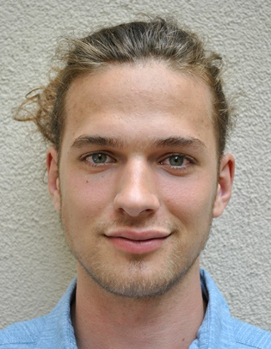
Bc. Josef Kořínek
Zelená 425, Ústí nad Labem 403 31
+420 732 478 964
Personal email: josefkorinek@bezobsahu.cz
School email: xkorj032@student.czu.cz
Born: 19. 2. 1998

Work experience
Manually works at Monza – Tonaso Group in the period: 2016
Operation and programming of CNC machines, assistant designer at SČA – Severočeská armaturka in the period: 2017-2018
Projektant assistant at Process Automation Solutions in the period: 2019

Education
Secondary Technical School, Ústí nad Labem, Resslova 5 in the period: 2014-2018
Mechanical Engineering with a focus on CNC machines and computer graphics
Bachelor's degree at the Czech University of Life Sciences Prague in the period: 2018 – 2021
Follow-up Master's degree at CULS in Prague in the period: 2021 - presence
Field of study Information and control technology in the agro-food complex

Further education
Driving license category B and C, autumn 2021
Certificate of completion of the training of CHVALIS s. r. o. on the topic basics of hydraulics March 2017
Obtaining the professional qualification Sports Massage 69-037-M, February 2019

Knowledge
English language – spoken form at level B2 written at level B1
Intermediate knowledge of technical drawing and 3D modeling in Autodesk Inventor and Fusion 360
Basic programming knowledge

Interests
Sport – from youth led to performance sport (figure skating 4 years, Latin American and standard dances 2 years, volleyball 6 years)
Healthy movement – recreational athlete, yoga, pilates, swimming and more
Music, dance, reading, self-development

